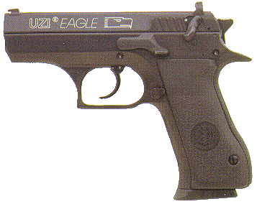
IMI Uzi Eagle Short Slide
Ammo | Mag | Rng | ROF | Dam | Arm
9mm P  .45 ACP | 10  10 | 12  8 | 2  2 | 1  2 | x2  x3
UZI Eagle Short Slide: Short slide version of the IMI M91. Available in both .45 and 9mm P. Excellent weapon, reliable in the worst conditions.
Nation: Israel & South Africa Weight: .85 kg
Ammunition: 9mm P / .45 ACP Magazine: 12 / 8
Price: $650 Availability: ( S/R )

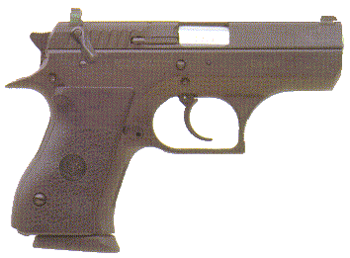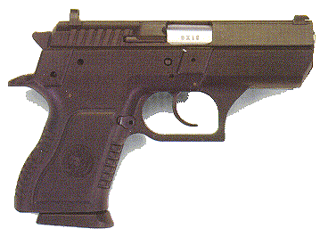
IMI Uzi Eagle Compact / Polymer Compact
Ammo | Mag | Rng | ROF | Dam | Arm
9mm P | 10 | 10 | 2 | 1 | x2
UZI Eagle Compact: A reliable compact handgun. The Eagle Compact has taken on the harsh desert conditions and still been able to fire as if it were locked away in a vacuum packed vault.
Nation: Israel & South Africa Weight: .65 / .60 kg
Ammunition: 9mm P Magazine: 10
Price: $550 Availability: ( S/R )

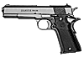
Llama Large Frame Automatic
Ammo | Mag | Rng | ROF | Dam | Arm
.45 ACP  9mm P | 8  10 | 10  15 | 2  2 | 2  1 | x3  x2
Llama Large Frame Automatic: A heavy-duty, automatic pistol, the Llama Large Frame comes in either .45 ACP or 9mm P. It is nearly identical in appearance to the Colt M1911A1, the most striking difference being the barrel rib.
Nation: Spain Weight: 1.12 kg
Ammunition: .45 ACP / 9mm P Magazine: 8 / 10
Price: $335 Availability: ( S/R )

Llama Small Frame Automatic
Ammo | Mag | Rng | ROF | Dam | Arm
.380 ACP  .22 LR | 7  10 | 10  15 | 2  3 | 1  0 | x3  x4
Llama Small Frame Automatic: As the name suggests, it is a smaller, lighter version of the Large Frame Automatic. Because of its similarity to the Colt M1911A1 in both appearance and operation, the Llama Small Frame has become extremely popular with NATO vehicle and aircraft crews.
Nation: Spain Weight: .644 kg
Ammunition: .380 ACP or .22 LR Magazine: 7 / 10
Price: $260 Availability: ( S/R )

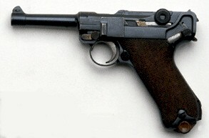
Luger P-08
Ammo | Mag | Rng | ROF | Dam | Arm
9mm P | 8 | 15 | 2 | 1 | x2
Luger P-08: Unique among handguns, the Luger is one of the most famous and easily recognizable automatic pistols in the world. Because of its distinctive toggle action and close parts tolerance, it is easy to jam simply from dirt getting into the weapon. Most Lugers are now owned by collectors, but because millions are in circulation, they must be included here.
Nation: Germany Weight: .87 kg
Ammunition: 9mm P Magazine: 8
Price: $1100 Availability: ( R/R )

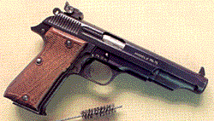
MAB-P15
Ammo | Mag | Rng | ROF | Dam | Arm
9mm P | 15 | 15 | 2 | 1 | x2
MAB-P15: The standard issue sidearm of the French military, the p15 has a simple action, high magazine capacity and is ruggedly built. It is considered one of the best French handguns designed.
Nation: France Weight: 1.09 kg
Ammunition: 9mm P Magazine: 8
Price: $550 Availability: ( C/S )

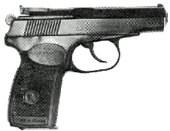
Makarov PM
Ammo | Mag | Rng | ROF | Dam | Arm
9mm M | 8 | 15 | 2 | 1 | x4
Makarov PM: The Makarov is the standard issue sidearm for the Soviet Union and in common use with other Warsaw Pact nations.
Nation: USSR Weight: .5kg
Ammunition: 9mm M Magazine: 8
Price: $400 Availability: ( S/V )

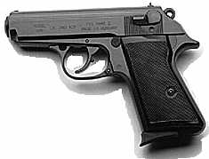
Manhurin Model PPK/s
Ammo | Mag | Rng | ROF | Dam | Arm
.22 LR  .32 ACP  .380 ACP | 10  8  7 | 15  9  10 | 3  2  2 | 0  1  1 | x4  x4  x3
Manhurin “Walther” Model PPK/s: Although originally designed and manufactured in Germany, since 1952 the PPK/S has been manufactured in France. It comes in three calibers: .22LR, .32 ACP, and .380 ACP. It is one of the weapons favored by the DGSE (French Military Intelligence).
Nation: France Weight: .64kg
Ammunition: .22 LR, .38, .380 Magazine: 10, 8, 7
Price: $435 Availability: ( S/ S )

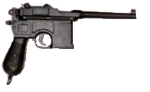
Mauser M1896
Ammo | Mag | Rng | ROF | Dam | Arm
.32 ACP | 10 | 11 | 2 | 1 | x4
Mauser M1896: Known as the “Broomhandle” Mauser, the M1896 was the first successful automatic pistol design. It was used by many countries and originally manufactured in Germany. By the late 1980’s, it had become a collector’s item. The M1896 has an integral magazine which is fed by a 10 round stripper clip.
Nation: Germany Weight: 1.13kg
Ammunition: .32 ACP Magazine: 10I
Price: $2000 Availability: ( R/R )

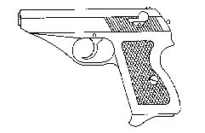
Mauser HSc
Ammo | Mag | Rng | ROF | Dam | Arm
9mm P | 7 | 10 | 2 | 1 | x2
Mauser HSc: A small pistol carried by the German Luftwaffe and Kriegsmarine during World War II. Like the M1896, the HSc is a collector’s item, but it is somewhat more scarce
Nation: Germany Weight: .6kg
Ammunition: 9mm P Magazine: 7
Price: $2400 Availability: ( / )

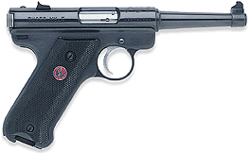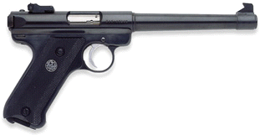
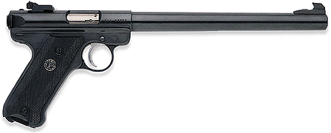
Ruger Mark II
Ammo | Mag | Rng | ROF | Dam | Arm
.22 LR | 10 | 15 | 3 | 0 | x4
Ruger Mk II: An American-made small caliber pistol, the Ruger Mk II has a reputation for reliability. It is distributed worldwide.
Nation: United States Weight: 1 kg
Ammunition: .22 LR Magazine: 10
Price: $275 Availability: ( C/S )

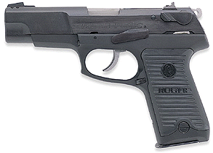
Ruger P-85
Ammo | Mag | Rng | ROF | Dam | Arm
9mm P | 10 | 15 | 2 | 1 | x2
Ruger P-85: In the late 1980s, politics and congressional pork barrelling had served to drastically slow down U.S. military procurement of the Beretta 92s. Several thousand P-85’s were purchased as a stopgap measure by the US Navy and Marine Corps. They proved to be excellent service pistols and by the time America entered the war, the Navy and Marines had over 10,000 P-85 pistols in their inventory.
Nation: United States Weight: .85kg
Ammunition: 9mm P Magazine: 12
Price: $500 Availability: ( C/S )

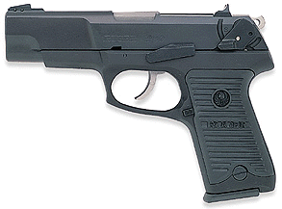
Ruger P89D / P90
Ammo | Mag | Rng | ROF | Dam | Arm
9mm P  .45 ACP | 10  7 | 15  10 | 2  2 | 1  2 | x2  x3
Ruger P89D / P90: Updated versions of the P85. These two firearms have set Ruger on the map for handguns, other than the Mark II, which they are most famous for. Customers now realize that Ruger doesn’t just make a good .22; Ruger makes a good gun. Period.
Nation: United States Weight: .85 kg
Ammunition: 9mm P / .45 ACP Magazine: 10 / 7
Price: $480 / $500 Availability: ( C/R )

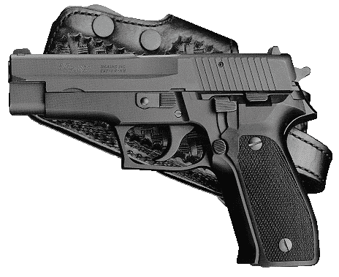
SIG / Sauer P-226
Ammo | Mag | Rng | ROF | Dam | Arm
9mm P | 10 | 15 | 2 | 1 | x2
SIG/Sauer P-226: A high quality Swiss-made handgun, the P-226 was a serious contender for the U.S. Army’s standard sidearm. Even though it lost out in that competition, the P-226 became popular with a number of police and law enforcement agencies worldwide.
Nation: Switzerland Weight: .84 kg
Ammunition: 9mm P Magazine: 10
Price: $585 Availability: ( S/R )

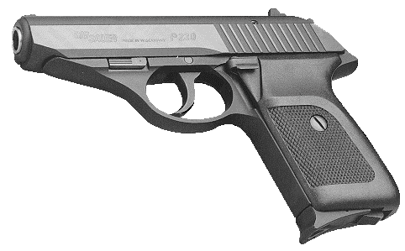
SIG / Sauer P-230
Ammo | Mag | Rng | ROF | Dam | Arm
9mm P | 7 | 10 | 2 | 1 | x2
SIG/Sauer P-230: A lightweight, easily concealable automatic pistol, the P-230 has found its way into a number of European police arsenals. It is also carried by some Luftwaffe flight crews.
Nation: Switzerland Weight: .45 kg
Ammunition: 9mm P Magazine: 7
Price: $475 Availability: ( S/R )

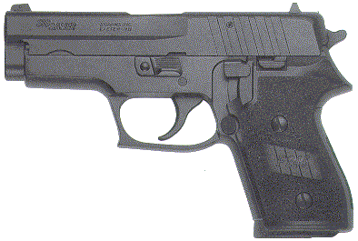
SIG Sauer P245
Ammo | Mag | Rng | ROF | Dam | Arm
.45 ACP | 6 / 8 | 10 | 2 | 2 | x3
SIG Sauer P245: The .45 ACP version of the dependable p-226.
Nation: Switzerland Weight: .95 kg
Ammunition: .45 ACP Magazine: 6 / 8
Price: $600 Availability: ( S/R )

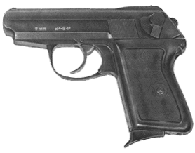
P-64
Ammo | Mag | Rng | ROF | Dam | Arm
9mm M | 7 | 15 | 2 | 1 | x4
P-64: the standard-issue sidearm of the Polish military, the P-64 fires the Soviet 9mm Makarov round. It is a reliable pistol, and is much sought by soldiers of the Warsaw Pact in 2000.
Nation: Poland Weight: .64 kg
Ammunition: 9mm M Magazine: 7
Price: $500 Availability: ( S/C )

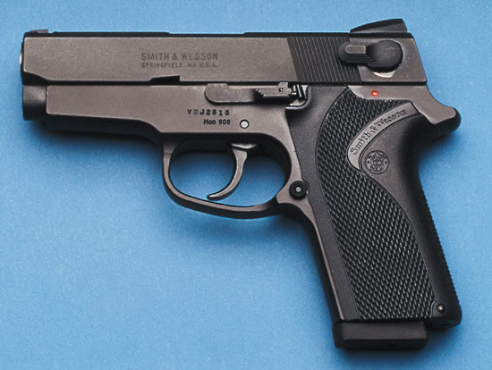
S & W Model 908
Ammo | Mag | Rng | ROF | Dam | Arm
9mm P | 10 | 15 | 2 | 1 | x2
S & W Model 908: An automatic pistol from a company far more famous for its revolvers (Smith and Wesson). The 908 is an updated version of the Model 459 that was in competition for replace the Colt M1911, for the standard sidearm of the U.S. Military.
Nation: United States Weight: .82 kg
Ammunition: 9mm P Magazine: 10
Price: $525 Availability: ( C/R )

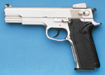
S & W Model 4506
Ammo | Mag | Rng | ROF | Dam | Arm
.45 ACP | 8 | 10 | 2 | 2 | x3
S & W Model 4506: The Model 4506 is a double-action pistol with an alloy frame. The Model 459 designed as a possible replacement for the M1911A1, but it lost out in the competition. The Model 4506 is an updated version of the
Nation: United States Weight: .85 kg
Ammunition: 9mm P Magazine: 10
Price: $525 Availability: ( C/R )

NO PHOTO

Steyr GB-80
Ammo | Mag | Rng | ROF | Dam | Arm
9mm P | 8 | 15 | 2 | 1 | x2
Steyr GB-80: A double-action, high magazine capacity automatic pistol, the GB-80 was adopted as the standard sidearm of the Australian Military. It is a highly efficient combat weapon.
Nation: Austria and Australia Weight: .88 kg
Ammunition: 9mm P Magazine: 8
Price: $850 Availability: ( S/R )

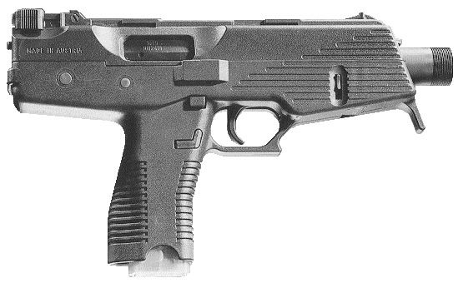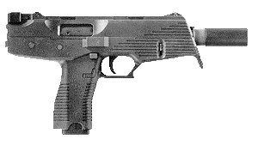
Steyr Special Purpose Pistol
Ammo | Mag | Rng | ROF | Dam | Arm
9mm P | 15 / 30 | 15 | 2 / 5 | 1 | x2
Steyr SPP: The Styer SPP is a semi-auto-only civilian version of the Steyr TMP (Tactical Machine Pistol), profiled in the nearby article by Belgian gun writer Jacques Lenearts. Extremely compact at under 12 inches overall, the TMP has selective fire capability that in full-auto carries a cyclic rate of 900 rpm.
Nation: Austria and Australia Weight: 1.2 kg
Ammunition: 9mm P Magazine: 15 / 30
Price: $1300 Availability: ( -/- )

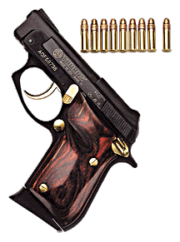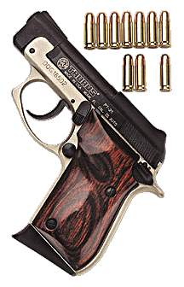
Taurus PT-22 / 25
Ammo | Mag | Rng | ROF | Dam | Arm
.22 LR  .25 ACP | 8  9 | 13  12 | 3  3 | 0  0 | x4  x4
PT-22 / 25: Taurus ventures into the compacts with these two palm-sized “plinkers.” Excellent design, prevents the slide from grabbing the hand of the user. Concealable, cheap and accurate. These are good “throw away” pistols. (“Throw aways” are weapons used for a deed and then disposed so as not to leave evidence.)
Nation: United States Weight: .60 kg
Ammunition: .22 LR / .25 ACP Magazine: 8 / 9
Price: $180 / $205 Availability: ( C/S )

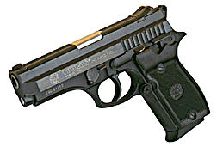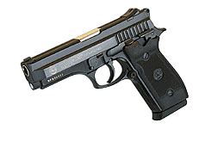
Taurus PT-938 / 911
Ammo | Mag | Rng | ROF | Dam | Arm
.380 ACP  9mm P | 10  10 | 10  15 | 2  2 | 1  1 | x3  x2
PT-938 / 911: Effective automatics, generally used for home and personal defense. These have not been incorporated into the military as standard sidearms, however these weapons do what they were made for. They shoot.
Nation: United States Weight: .95 kg
Ammunition: .380 ACP / 9mm P Magazine: 10 / 10
Price: $435 / $450 Availability: ( C/S )

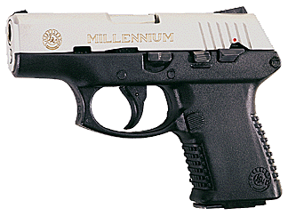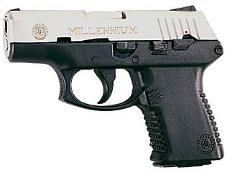
Taurus PT-138 / 111
Ammo | Mag | Rng | ROF | Dam | Arm
.380 ACP  9mm P | 10  10 | 10  15 | 2  2 | 1  2 | x3  x2
Taurus PT-138/111: The “Millenium” is a handy back-up weapon. Made of high grade metals and new polymers. It’s lighter than the other all-metal handguns, and just as effective. Not too mention, it doesn’t look too bad.
Nation: United States Weight: .68 kg
Ammunition: .380 ACP / 9mm P Magazine: 10 / 10
Price: $365 / $375 Availability: ( / )

